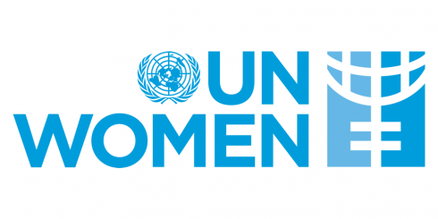
International Women’s Month 2022
Egumeni Session
Theme: "Gender Equality Today for a Sustainable Tomorrow”
When: 31st March 2022 Time: 15h00 - 17h00 (GMT+3)
Agenda
Time | Duration | Activity | Moderator
14:55 -15:00 | 5 mins | Song: Earth Song  https://www.youtube.com/watch?v=XAi3VTSdTxU | Tech
15:00 - 15:05 | 05 mins | Opening and Introduction by Dr Edward Addai, UNICEF Representative to the AU and ECA | Rewan / AUC
15:00 - 15:10 | 05 mins | Opening Remarks: H.E. Bineta Diop (AU Special Envoy on Women, Peace, and Security)
15:10 -15:15 | 05 mins | Video: Behind the Missions (DCP) | Tech
15:20 -15:30 | 05 mins  05 mins | Keynote Speech: H.E. Josefa Leonel Correia Sacko, Commissioner for Rural Economy and Agriculture, African Union Commission  Keynote Speech: Mme Awa Ndiaye Seck, UN Women Special Representative to AU and UNECA | Rewan / AUC
15:30-15:35 | 05 mins | Virtual game with panellists | Janice /AUC
15:35 -15:55 | 15 mins | Deep Dive 1: Climate Change and Financial and Economic Inclusion  - What climate mitigation and adaptation policies in particular exist towards improving women’s financial inclusion and advancing economic justice on the continent? Sara Eliasson, Junior Professional Officer in Climate Change Programme Management, RCC Uganda  - What's the role of CSOs in bridging the financial inclusion gap in climate change and advancing economic justice? Dr. Melania Chiponda, Human Rights Defender based in focusing on women’s economic, social and cultural rights, particularly women living in rural areas  - How can the economic empowerment of women foster low-carbon sustainable development and poverty reduction, and increase the potential for adaptation on the African continent? Elena Ruiz Abril, UN Women’s Regional Policy Advisor for Women’s Economic Empowerment for West and Central Africa | Rewan / AUC
15:55 -16:00 | 05 mins | Happy International Women’s Month Video | Tech
16:00 - 16:15 | 15 mins | Deep Dive 2: Climate Change and Food Security  - What challenges does climate change pose to food security? Vere Shaba, Founder and CEO of Greendesign Africa  - Women are an essential asset in the fight against climate change. Why is gender equality the missing link between food security and climate change? S.E. Zahra KAMIL ALI, Représentante permanente de l’Organisation Internationale de la Francophonie auprès de l’Union Africaine  - Which gender-responsive strategies, policies, and programs do we leverage as best practices for advancing sustainable consumption and production, including fostering regenerative food and agricultural systems within the continent? Dr. Godfrey Bahiigwa, Director of the Department of Rural Economy and Agriculture, AUC | Janice / AUC
16:15 - 16:25 | 10 mins | Q & A Session | Janice / AUC
16:25 - 16: 30 | 05 mins | Closing Session:  Key messages, actions and recommendations by Dr. Rewan Youssif, Youth Division, AUC
16:30 -16:40 | 10 mins | Closing remarks by Ms. Victoria Maloka, Head of Coordination and Outreach Division, AUC | Rewan / AUC
Music!!!

