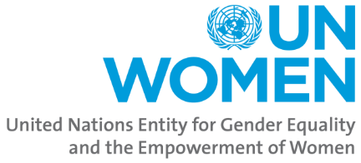

**UNW/ESAR/SSD/CFP/2023/004**

**Call for Proposal (CFP) for Responsible Parties for Civil Society Organizations – CSOs/National Non-Government Organizations (NNGOs)/International Non-Government Organizations (INNGOs)**

UN Women, grounded in the vision of equality enshrined in the Charter of the United Nations, works for the elimination of discrimination against women and girls; the empowerment of women; and the achievement of equality between women and men as partners and beneficiaries of development, human rights, humanitarian action and peace and security.

UN Women South Sudan Office seeks to engage partners to support the implementation of South Sudan Women Social and economic Empowerment Project (SSWSEEP) – Component 1. The potential partners submitting proposals should possess the requisite experience and a proven record of innovative and high-impact programmes community empowerment for women and girls as detailed in the Terms of reference.

In this regard, this is to notify you that the UN Women Country Office Call for Proposal has now been published and can be accessed using the link below: <https://africa.unwomen.org/en/programme-implementation/2023/09/community-empowerment-support-to-women-and-girls-of-the-sswseep-project>

**Important to note:**

1. Requests for clarifications should be sent to: (Via e-mail): southsudan.procurement@unwomen.org

The bides clarification meeting shall be called on 27/09/2023 and shall be entirely virtual [<https://unwomen.zoom.us/j/94449067995?pwd=V0luMmpyNjBDVitUdVFRYzBpTVhIQT09>] starting 11:00hrs Juba time

1. Proposals must be received by UNWOMEN ONLINE not later **than 17:00hrs on October 13th, 2023**. Please mark the submission parcels as guided in the CFP.